**EXCHANGE OF VARIABLES**

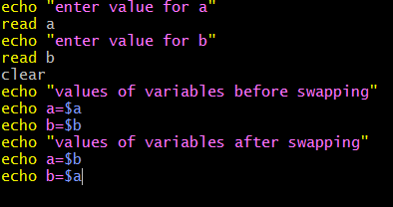

**OUTPUT**

